**Jacob Benavides acting resume**

**  **

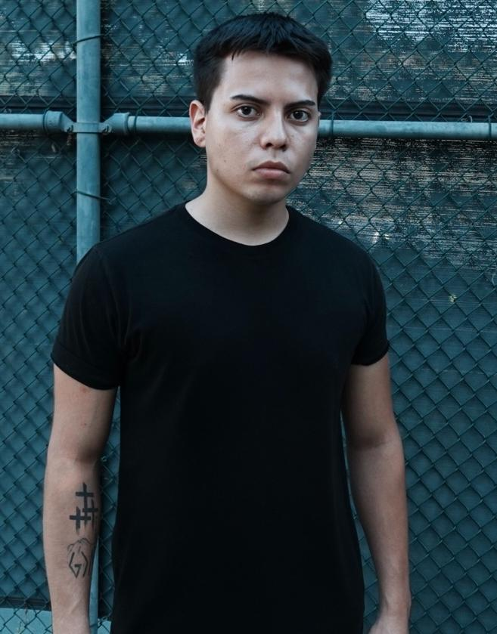

**ACTING REEL LINK:** [**https://youtu.be/NPNOfHB2qw0?si=gJHo6jEj4pH6nffN**](https://youtu.be/NPNOfHB2qw0?si=gJHo6jEj4pH6nffN)

**Contact details:**

Email: [Jacoballer440@gmail.com](mailto:Jacoballer440@gmail.com)

Phone: 571-359-5626

Instagram: jacobbenavides_

Imdb: https://www.imdb.com/name/nm13205637/

**Credits :**

**Film :**

Adrenaline Junkies **feature film** (in production) ( Lead)

Vaccinated pt 1 Million Dollar Movie short film ( Lead )2023

Right road lost short film ( supporting ) 2022

All american season 6 **netflix** ( background )2024

Grownish season 7 **hulu** ( Background ) 2024

Candy Cane Lane (Dayplayer) 2023

Jack and lou a gangster love story (Background) 2023

**Commercial :** Kenya moore hair commercial ( supporting ) 2023

**Television:**

Stoned breakups( Supporting ) 2022

**WebVideo:** I dated 50 kens in 24 hours ( supporting ) 2023

**Bio :**

Eye color : brown

Height : 5’7

Hair color : Brown

Weight : 145 lbs

Age : 20

Birthday : October 3rd , 2003

Union status : non union

**Acting Training :**

- Meisner technique trained

-Acting technique trained

-Improved trained

Ltm actor workshop , patriot high school theater department , lacc theater acting department .

**Manager :** Linda Townsend

**COVER LETTER:**  Greetings, my name is Jacob Benavides. I am a 20 year old young actor who lives in Los Angeles. I have infinite passion and love for acting. What I can bring to the table is that I am a super competitive and hardworking young actor who will submit my auditions via self tape or in person early and high quality, who will show up early and work , who will be a team player meaning I will do what is best for the team instead of doing what's best for myself , who will motivate my peers in any way I possibly can. I understand that my look is what gets me booked and for that reason I go to the gym every single day to maintain my look. I am always looking to take my game to the next level. I absolutely love the teamwork aspect that comes with being on set . I also love the discipline that comes with acting . I am more than ready and prepared to show up and work if called . Thank you very much.